M.Abdullah.Mahmood
BCS-3B
22f-3289
DS-Lab 10
To: Sir Saqib Ameer
______________________________________________
Task 1:
#include <iostream>
#include <queue>
using namespace std;

class Btree {
public:
int val;
Btree* leftChild;
Btree* rightChild;

Btree() {
leftChild = NULL;
rightChild = NULL;
}
Btree(int va) {
val = va;
leftChild = NULL;
rightChild = NULL;
}

~Btree() {
delete leftChild;
delete rightChild;
}
};

Btree* insertion(int v, Btree* rot) {
if (rot == NULL) {
rot = new Btree(v);
}
else if (v < rot->val) {
rot->leftChild = insertion(v, rot->leftChild);
}
else if (v > rot->val) {
rot->rightChild = insertion(v, rot->rightChild);
}
else
cout << "value already exists \n";
return rot;
}

Btree* buildTree() {
Btree* root = new Btree();
int val = -1;
while (val != 0) {
cout << "enter value: ";
cin >> val;
if (val != 0) {
root = insertion(val, root);
}
}
return root;
}

bool isEmpty(Btree* t) {
return (t == NULL ? true : false);
}

void inorderTraversal(Btree* root) {
if (root == NULL)
return;

inorderTraversal(root->leftChild);
cout << root->val << " ";
inorderTraversal(root->rightChild);
}

void postorderTraversal(Btree* root) {
if (root == NULL)
return;

postorderTraversal(root->leftChild);
postorderTraversal(root->rightChild);
cout << root->val << " ";
}

void preorderTraversal(Btree* root) {
if (root == NULL)
return;

cout << root->val << " ";
preorderTraversal(root->leftChild);
preorderTraversal(root->rightChild);
}

bool searchNode(Btree* rot, int v) {
if (rot == NULL)
return false;

if (rot->val == v)
return true;
else if (v < rot->val)
return searchNode(rot->leftChild, v);
else
return searchNode(rot->rightChild, v);
}

void makeDeletion(Btree*& root) {
Btree* temp;
if (root->rightChild == NULL) {
temp = root;
root = root->leftChild;
delete temp;
}
else if (root->leftChild == NULL) {
temp = root;
root = root->rightChild;
delete temp;
}
else {
temp = root->rightChild;
while (temp->leftChild) {
temp = temp->leftChild;
}

temp->leftChild = root->leftChild;
temp = root;
root = root->rightChild;
delete temp;
}
}

void deleteNode(Btree*& rot, int v) {
if (rot == NULL) {
cout << v << "not found";
}
else if (v < rot->val) {
deleteNode(rot->leftChild, v);
}
else if (v > rot->val) {
deleteNode(rot->rightChild, v);
}
else {
makeDeletion(rot);
}

}

int main() {
Btree* tre = NULL;

tre = buildTree();

//empty or not
if (isEmpty(tre))
cout << "tree is empty \n";
else
cout << "tree is not empty \n";

cout << "Inorder Traversal: ";

//inorder traversal
inorderTraversal(tre);
cout << endl;

//postorder traversal
cout << "Postorder Traversal: ";
postorderTraversal(tre);
cout << endl;

//preorder traversal
cout << "Preorder Traversal: ";
preorderTraversal(tre);
cout << endl;

//searchNode
if (searchNode(tre, 7))
cout << "node found \n";
else
cout << "node not found\n";

//deletion node
deleteNode(tre, 7);

//inorder after deletion
inorderTraversal(tre);

return 0;
}

Output:
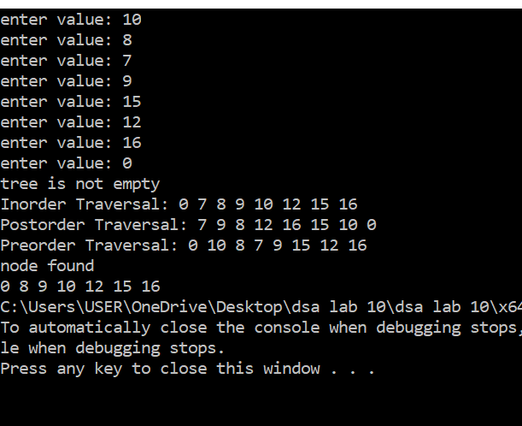

Task 2:
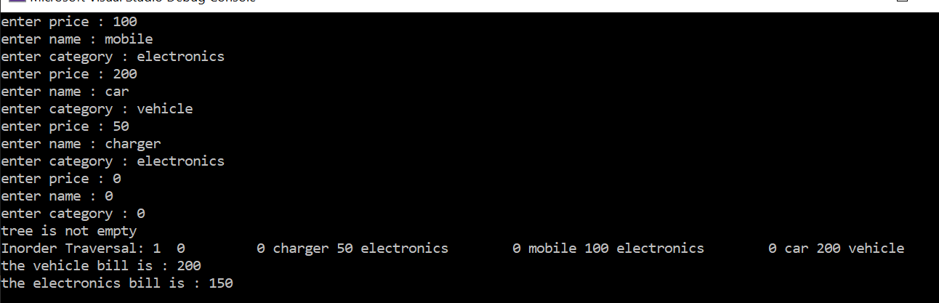

#include <iostream>
using namespace std;

int vehicalBill = 0;
int electronicBill = 0;

class Btree {
public:
int id,price;
string name, category;

Btree* leftChild;
Btree* rightChild;

Btree() {
id = 0001;
price = 0;
category = "";
name = "";
leftChild = NULL;
rightChild = NULL;
}
Btree(int p,string c,string n) {
price = p;
category = c;
name = n;
leftChild = NULL;
rightChild = NULL;
}

~Btree() {
delete leftChild;
delete rightChild;
}
};

Btree* insertion(int p,string c ,string n, Btree* rot) {
if (rot == NULL) {
rot = new Btree(p,c,n);
}
else if (p < rot->price) {
rot->leftChild = insertion(p,c,n,rot->leftChild);
}
else if (p > rot->price) {
rot->rightChild = insertion(p,c,n,rot->rightChild);
}
else
cout << "value already exists \n";
return rot;
}

Btree* buildTree() {
Btree* root = new Btree();
int price = -1;
string name, category;
while (price != 0) {

cout << "enter price : ";
cin >> price;
cout << "enter name : ";
cin >> name;
cout << "enter category : ";
cin >> category;

if (price!= 0) {
root = insertion(price,category,name, root);
}
}
return root;
}

bool isEmpty(Btree* t) {
return (t == NULL ? true : false);
}

void inorderTraversal(Btree* root) {
if (root == NULL)
return;

if( root->category == "vehicle") {
vehicalBill += root->price;
}
else {
electronicBill += root->price;
}

inorderTraversal(root->leftChild);
cout << root->id << " "<<root->name << " "<<root->price<<" "<<root->category<<"\t";
inorderTraversal(root->rightChild);
}

int main() {
Btree* tre = NULL;

tre = buildTree();

//empty or not
if (isEmpty(tre))
cout << "tree is empty \n";
else
cout << "tree is not empty \n";

cout << "Inorder Traversal: ";

//inorder traversal
inorderTraversal(tre);
cout << endl;

cout << "the vehicle bill is : " << vehicalBill << endl;
cout << "the electronics bill is : " << electronicBill << endl;

return 0;
}

